**Think Bridge Coding Test**

Project link :

<https://github.com/pushpavarsha/ThinkBridge.git>

<https://github.com/pushpavarsha/ThinkBridge>

Database : Database related files are also there in mentioned link.

Add the Database file in the SQL Server in your System :

|  |
| --- |
| <add name="ThinkBridgeEntities" connectionString="metadata=res://*/Models.TeaModel.csdl|res://*/Models.TeaModel.ssdl|res://*/Models.TeaModel.msl;provider=System.Data.SqlClient;provider connection string=&quot;data source=(LocalDb)\MSSQLLocalDB;initial catalog=ThinkBridge;integrated security=True;MultipleActiveResultSets=True;App=EntityFramework&quot;" providerName="System.Data.EntityClient" /> |

Change the connection string in each project of solution.

Technologies Used:

1. .Net MVC Framework
2. C#
3. Repository Pattern
4. Front End : JQuery,Html,CSS
5. BackEnd :SQL Server
6. Middle Layer : Web Api
7. Entity Framework
8. Linq
9. Unit Test Project
10. All Operation : Insert,Delete,Update,Get

Database Side: Three tables:

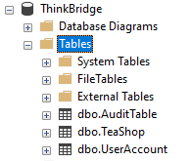

Project Architecture

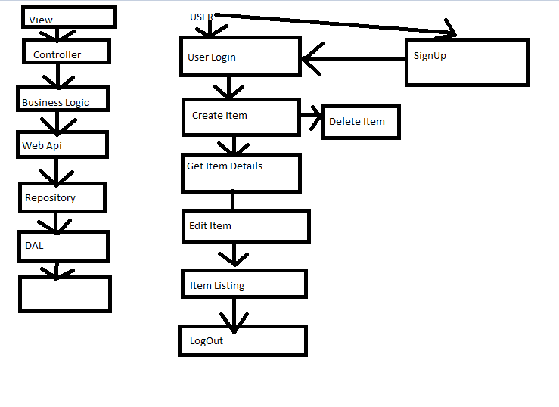

Representation:

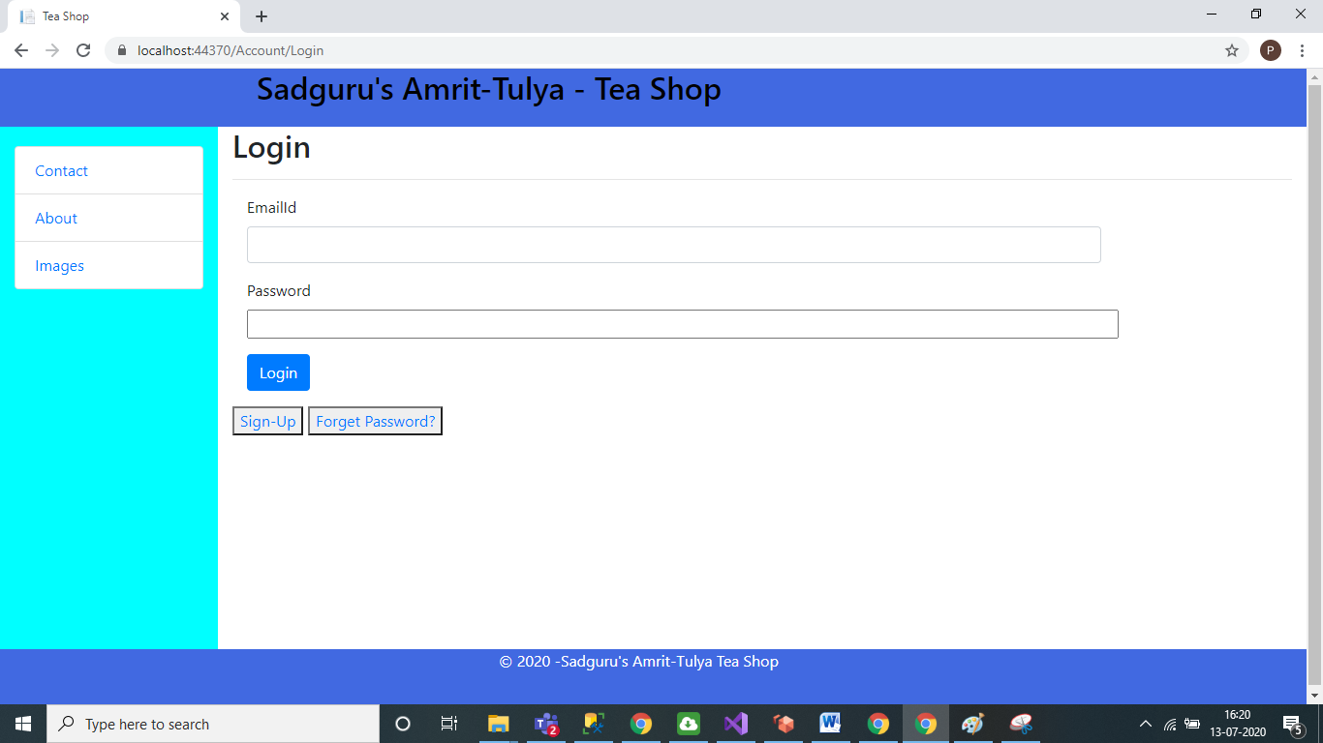

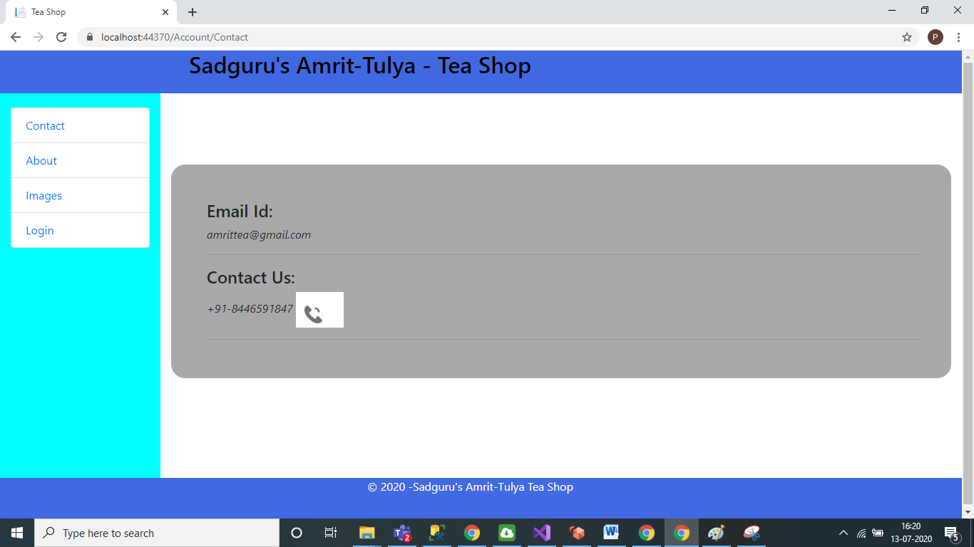

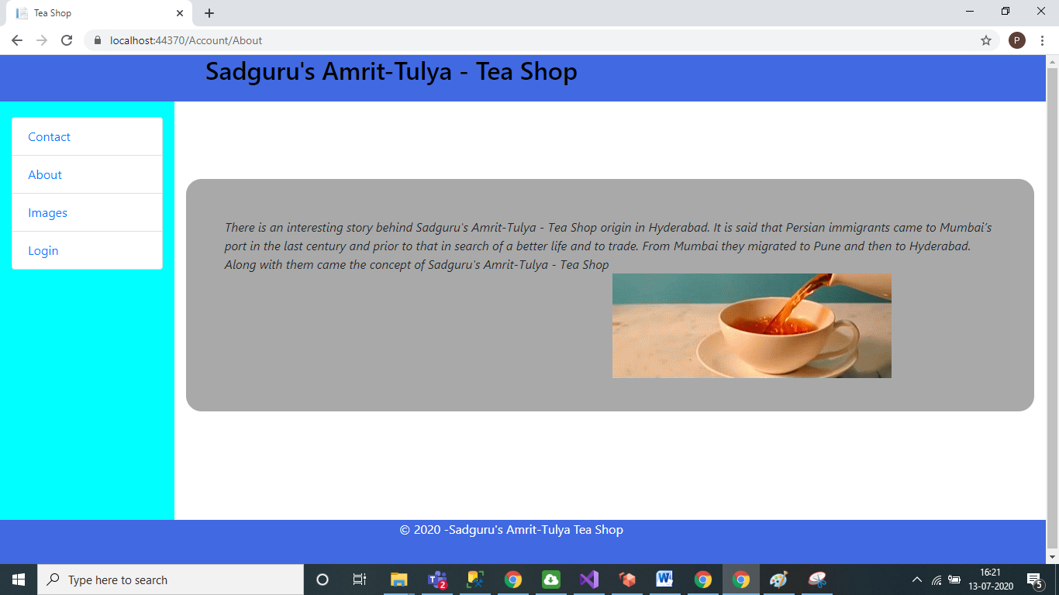

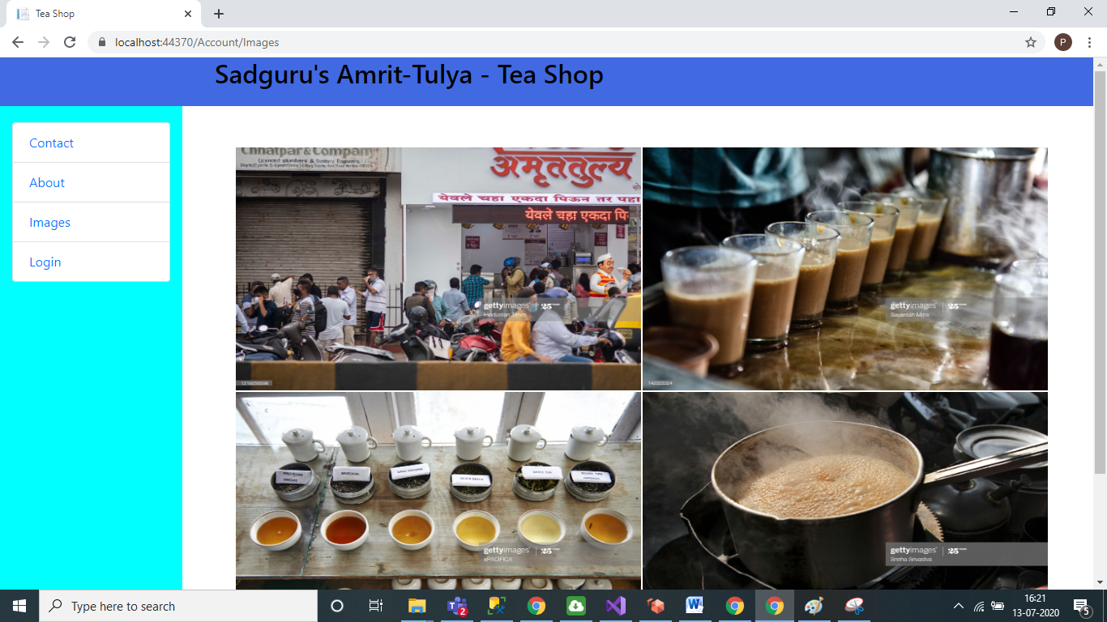

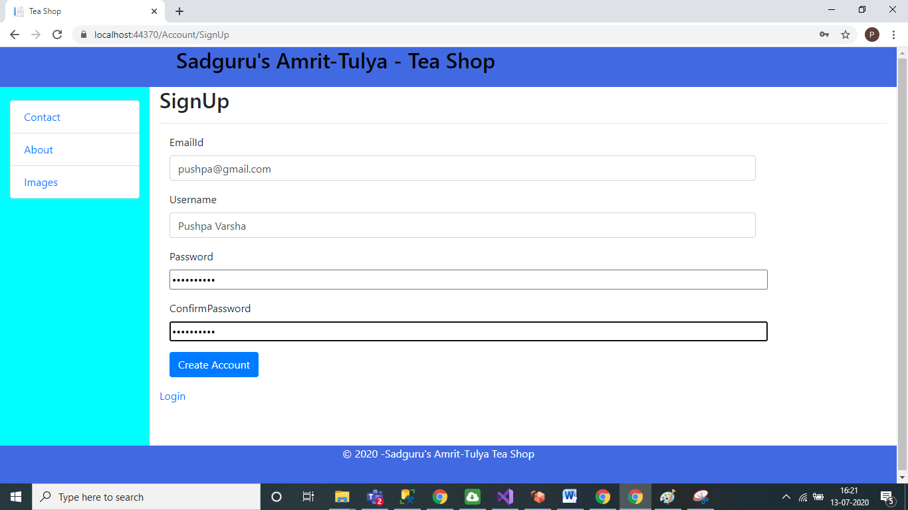

After Login

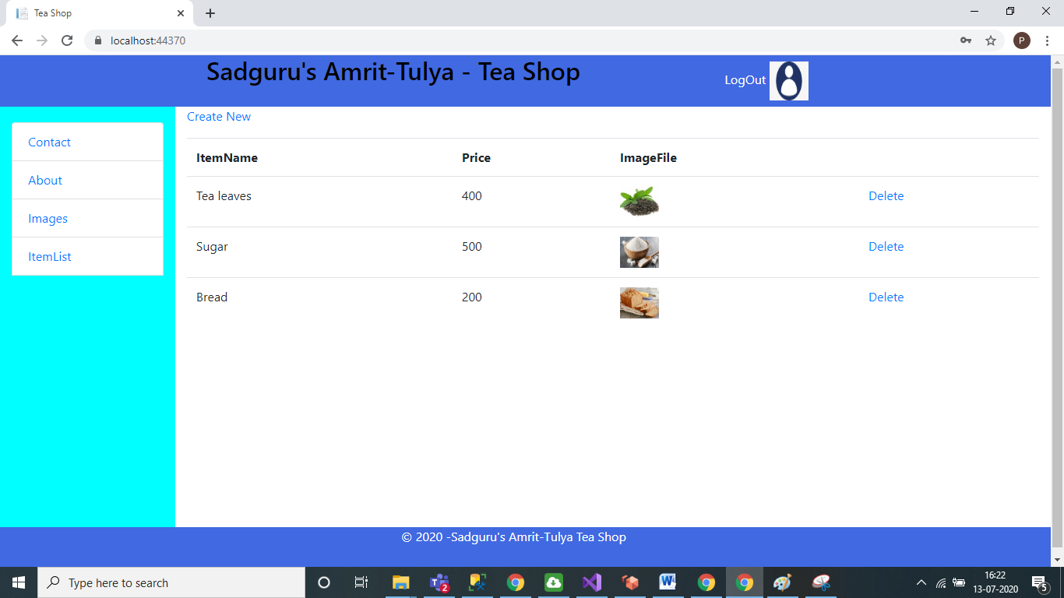

Create Item:

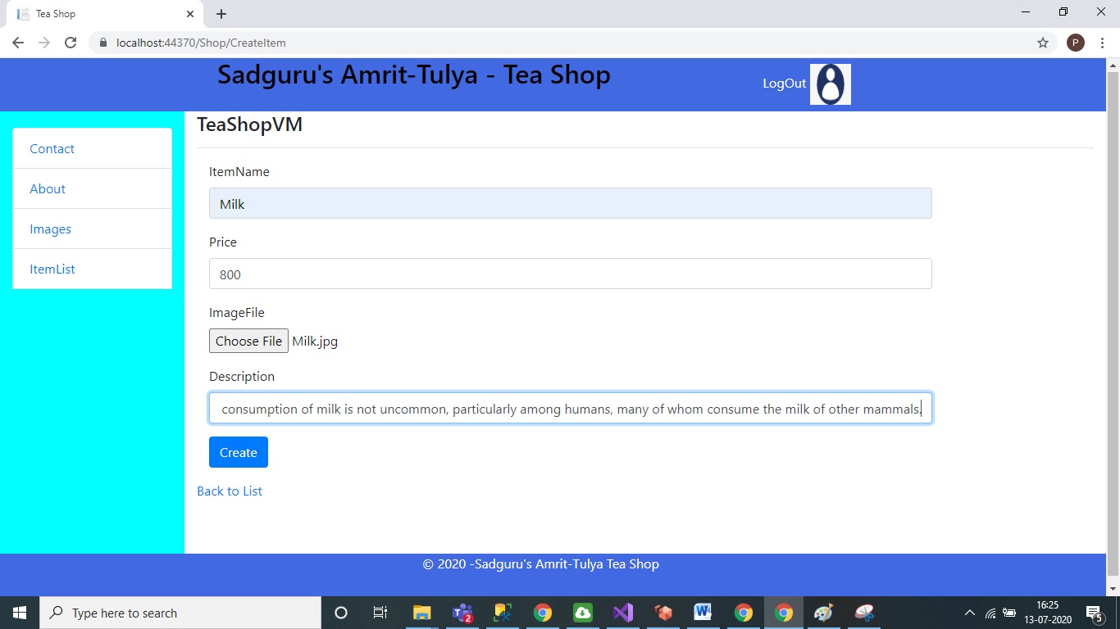

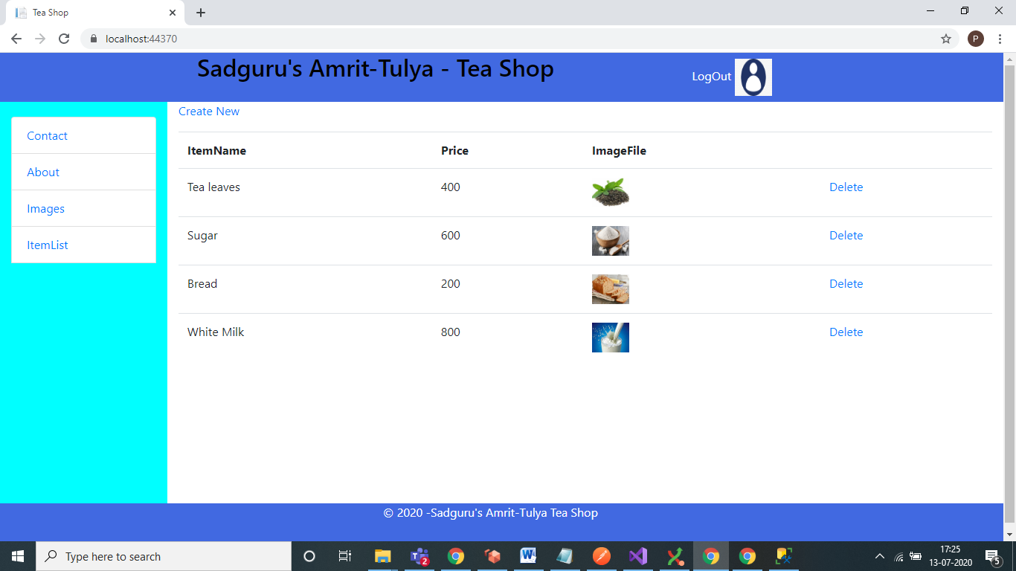

Click on Logout.

